Project Title: Apple iTunes Music Analysis
Status Completed
Timing Date to Date
Owners yelavarthi suchitra

Overview

Welcome to the domain of Music Store SQL Data Analysis, an advanced exploration into the intricacies of online music stores. This comprehensive project dives deep into the world of relational databases, leveraging the powerful combination of PostgreSQL,PowerBI and PgAdmin4 to unravel the complexities of a meticulously curated music dataset.This repository contains an end-to-end data analytics project analyzing the iTunes Music Store using SQL and power BI. The project explores customer behavior, revenue trends, genre/artist popularity, employee performance, and operational insights to assist business decisions.

Objectives

Learning objectives
Our primary objective is to reveal subtle patterns within the music dataset, empowering you to tackle complex business challenges with confidence. Designed for beginners and seasoned SQL enthusiasts alike, this project aims to elevate your proficiency by applying real-world SQL queries to analyze comprehensive data.

Data description
A detailed exploration awaits as we delve into the intricacies of the music playlist database. Through the lens of advanced SQL queries, we aim to uncover nuanced patterns in customer behavior, sales dynamics, and genre preferences, offering a profound understanding of the dataset.

What to Expect
Query Solutions: A series of meticulously crafted SQL queries, each accompanied by insightful solutions.

Detailed Documentation: A comprehensive methodology that translates discovered insights into actionable strategies.

Project Resources: Insights into dataset analysis, toolset utilization, and educational focus.

Join us on this journey as we navigate the music store dataset, providing you with valuable insights and SQL skills that bridge the gap between theoretical knowledge and practical application.

Let's uncover the stories within the music store dataset together!

Power BI Visualizations
Organized by analysis phases:

🔶 Customer & Sales Overview
- Bar chart: Customers per Employee
- Card: Avg. Days Between Purchases

🔷 Revenue & Payment Insights
- Line chart: Monthly Revenue Trend
- Column chart: Quarterly Revenue Comparison
- Card: Total Revenue

🌿 Genre, Artist, and Track Popularity
- Bar chart: Top 10 Tracks by Revenue
- Horizontal bar chart: Top Artists by Revenue
- Table: Most Common Composers
- Table: Overpriced Tracks (Unit Price vs Duration)

🟡 Region & Employee Performance
- Map: Revenue by Country
- Bar chart: Revenue by Region (Employee Location)
- Bar chart: Revenue by Employee

🔵 Retention & Optimization
- Card: Avg. Customer Lifetime Value
- Pie chart: Media Type Usage
- Pie chart or card: % of Customers with Multi-Genre Purchases
- Table: Underserved Countries
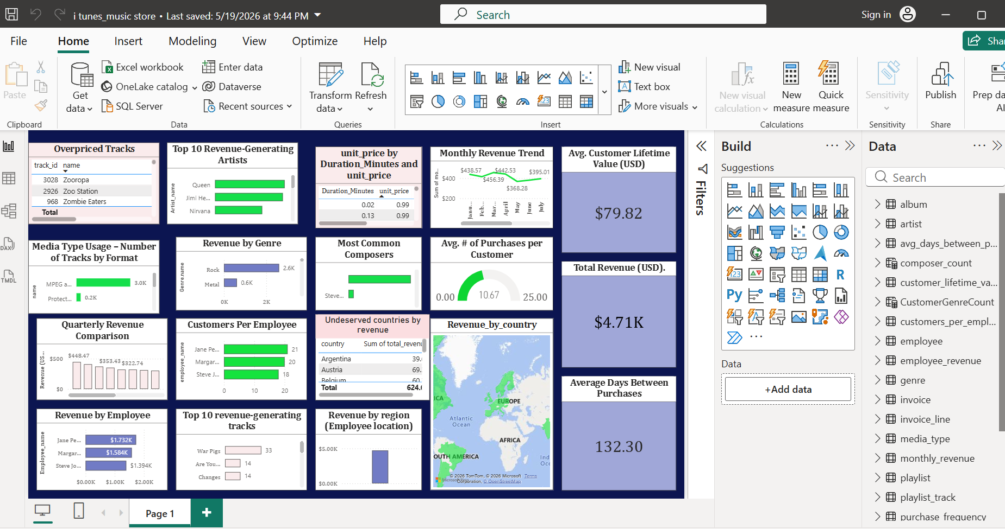

QUERY SOLUTIONS
-- Q1. Who is the senior most employee based on job title?

SELECT *
FROM employee
ORDER BY levels DESC
LIMIT 1;

-- Q2. Which countries have the most Invoices?

SELECT COUNT(invoice_id) AS invoice, billing_country AS billing_country
FROM invoice
GROUP BY billing_country
ORDER BY billing_country DESC;

-- Q3. What are top 3 values of total invoice?

SELECT *
FROM invoice
ORDER BY total DESC
LIMIT 3;

-- Q4. Which city has the best customers? We would like to throw a promotional Music Festival in the city we made the most money.
-- Write a query that returns one city that has the highest sum of invoice totals. Return both the city name & sum of all invoice totals.

SELECT billing_city, SUM(total) AS total
FROM invoice
GROUP BY billing_city
ORDER BY total DESC
LIMIT 1;

-- Q5. Who is the best customer? The customer who has spent the most money will be declared the best customer.
-- Write a query that returns the person who has spent the most money.

SELECT c.customer_id, c.first_name, c.last_name, SUM(i.total) AS total
FROM customer c
JOIN invoice i ON c.customer_id = i.customer_id
GROUP BY c.customer_id
ORDER BY total DESC
LIMIT 1;

-- Q6. Write a query to return the email, first name, last name, & Genre of all Rock Music listeners. Return your list ordered alphabetically by email starting with A

SELECT DISTINCT email, first_name, last_name
FROM customer
JOIN invoice ON customer.customer_id = invoice.customer_id
JOIN invoice_line ON invoice.invoice_id = invoice_line.invoice_id
WHERE track_id
IN (SELECT track_id
FROM track
JOIN genre ON genre.genre_id = track.genre_id
WHERE genre.name LIKE 'Rock')
ORDER BY email;

-- Q7. Let's invite the artists who have written the most rock music in our dataset.
-- Write a query that returns the Artist name and total track count of the top 10 rock bands.

SELECT artist.artist_id, artist.name, COUNT(track.track_id) AS num_of_songs
FROM artist
JOIN album ON album.artist_id = artist.artist_id
JOIN track ON track.album_id = album.album_id
WHERE genre_id
IN (SELECT genre_id
FROM genre
WHERE name LIKE 'Rock')
GROUP BY artist.artist_id
ORDER BY num_of_songs DESC
LIMIT 10;

-- Q8. Return all the track names that have a song length longer than the average song length.
-- Return the Name and Milliseconds for each track. Order by the song length with the longest songs listed first.

SELECT name, milliseconds
FROM track
WHERE milliseconds > (SELECT AVG(milliseconds) as avg_track_length
FROM track)
ORDER BY milliseconds DESC;

-- Q9. Find how much amount spent by each customer on artists. Write a query to return the customer name, artist name, and total spent.

WITH best_selling_artist AS
(SELECT artist.artist_id AS artist_id,
artist.name AS artist_name,
SUM(invoice_line.unit_price * invoice_line.quantity) AS total_spent
FROM invoice_line
JOIN track ON track.track_id = invoice_line.track_id
JOIN album ON album.album_id = track.album_id
JOIN artist ON artist.artist_id = album.artist_id
GROUP BY 1
ORDER BY 3 DESC)
SELECT c.customer_id AS customer_id,
c.first_name AS name,
bsa.artist_name AS artist_name,
SUM(il.unit_price * il.quantity) AS total_spent
FROM invoice i
JOIN customer c ON c.customer_id = i.customer_id
JOIN invoice_line il ON il.invoice_id = i.invoice_id
JOIN track t ON t.track_id = il.track_id
JOIN album al ON al.album_id = t.album_id
JOIN best_selling_artist bsa ON bsa.artist_id = al.artist_id
GROUP BY 1, 2, 3
ORDER BY 4 DESC;

-- Q10. We want to find out the most popular music Genre for each country.
-- We determine the most popular genre as the genre with the highest amount of purchases.
-- Write a query that returns each country along with the top Genre. For countries where the maximum number of purchases is shared return all Genres.

WITH popular_genre AS
(SELECT COUNT(invoice_line.quantity) AS purchases,
customer.country, genre.name AS genre_name,
ROW_NUMBER()
OVER(PARTITION BY customer.country
ORDER BY COUNT(invoice_line.quantity) DESC)AS row_num
FROM invoice_line
JOIN invoice ON invoice.invoice_id = invoice_line.invoice_id
JOIN customer ON customer.customer_id = invoice.customer_id
JOIN track ON track.track_id = invoice_line.track_id
JOIN genre ON genre.genre_id = track.genre_id
GROUP BY 2,3
ORDER BY 2 ASC, 1 DESC)
SELECT country, genre_name, purchases
FROM popular_genre
WHERE row_num <= 1;

-- Q11. Write a query that determines the customer that has spent the most on music for each country. Write a query that returns the country along with the top customer and how much they spent. For countries where the top amount spent is shared, provide all customers who spent this amount.

WITH customer_with_country AS
(SELECT customer.customer_id, first_name, last_name, billing_country, SUM(total) AS total_spent,
ROW_NUMBER() OVER(PARTITION BY billing_country ORDER BY SUM(total) DESC) AS row_num
FROM invoice
JOIN customer ON customer.customer_id = invoice.customer_id
GROUP BY 1,2,3,4
ORDER BY 4, 5 DESC)
SELECT customer_id, first_name, last_name, billing_country, total_spent
FROM customer_with_country
WHERE row_num = 1;

-- Q12. Who are the most popular artists?

SELECT COUNT(invoice_line.quantity) AS purchases, artist.name AS artist_name
FROM invoice_line
JOIN track ON track.track_id = invoice_line.track_id
JOIN album ON album.album_id = track.album_id
JOIN artist ON artist.artist_id = album.artist_id
GROUP BY 2
ORDER BY 1 DESC;

-- Q13. Which is the most popular song?

SELECT COUNT(invoice_line.quantity) AS purchases, track.name AS song_name
FROM invoice_line
JOIN track ON track.track_id = invoice_line.track_id
GROUP BY 2
ORDER BY 1 DESC;

-- Q14. What are the average prices of different types of music?

WITH purchases AS
(SELECT genre.name AS genre, SUM(total) AS total_spent
FROM invoice
JOIN invoice_line ON invoice.invoice_id = invoice_line.invoice_id
JOIN track ON track.track_id = invoice_line.track_id
JOIN genre ON genre.genre_id = track.genre_id
GROUP BY 1
ORDER BY 2)
SELECT genre, CONCAT('$', ROUND(AVG(total_spent))) AS total_spent
FROM purchases
GROUP BY genre;

-- Q15. What are the most popular countries for music purchases?

SELECT COUNT(invoice_line.quantity) AS purchases, customer.country
FROM invoice_line
JOIN invoice ON invoice.invoice_id = invoice_line.invoice_id
JOIN customer ON customer.customer_id = invoice.customer_id
GROUP BY country
ORDER BY purchases DESC;

Detailed Documentation

Methodology

In the methodology phase, we focus on translating the insights derived from our dataset analysis into actionable strategies. The goal is to provide the music store with scalable solutions tailored to real-world business needs. This involves careful consideration of discovered patterns and trends, aiming to enhance operational efficiency, elevate customer satisfaction, and optimize revenue streams. By implementing these practical implications, we aspire to offer tangible benefits that contribute to the overall success of the business.

Project Resources
1. Dataset Analysis: Embark on an in-depth examination of the music playlist database using advanced SQL queries. This crucial analysis unveils nuanced patterns in customer behavior, sales dynamics, and genre preferences. By scrutinizing every aspect of the dataset, we aim to extract valuable insights that inform strategic decision-making.
1. Toolset Utilization
PostgreSQL: PostgreSQL, a robust open-source relational database management system (RDBMS), stands at the core of our toolset. It excels in efficiently storing and managing structured data, providing a reliable foundation for our comprehensive data analysis.

PgAdmin4: PgAdmin4, a graphical user interface (GUI) designed for PostgreSQL, simplifies the execution and analysis of SQL queries. Its user-friendly features enhance the accessibility and efficiency of our data exploration, ensuring a seamless analytical experience.

Educational Focus: Tailored for beginners seeking to elevate their SQL proficiency, our project places a strong emphasis on real-world application. By providing hands-on experience with SQL queries, we enable comprehensive data analysis and empower learners to bridge the gap between theoretical knowledge and practical skills.

Schema Diagram
Visualize the intricate architecture of the music store database with the comprehensive schema diagram below:

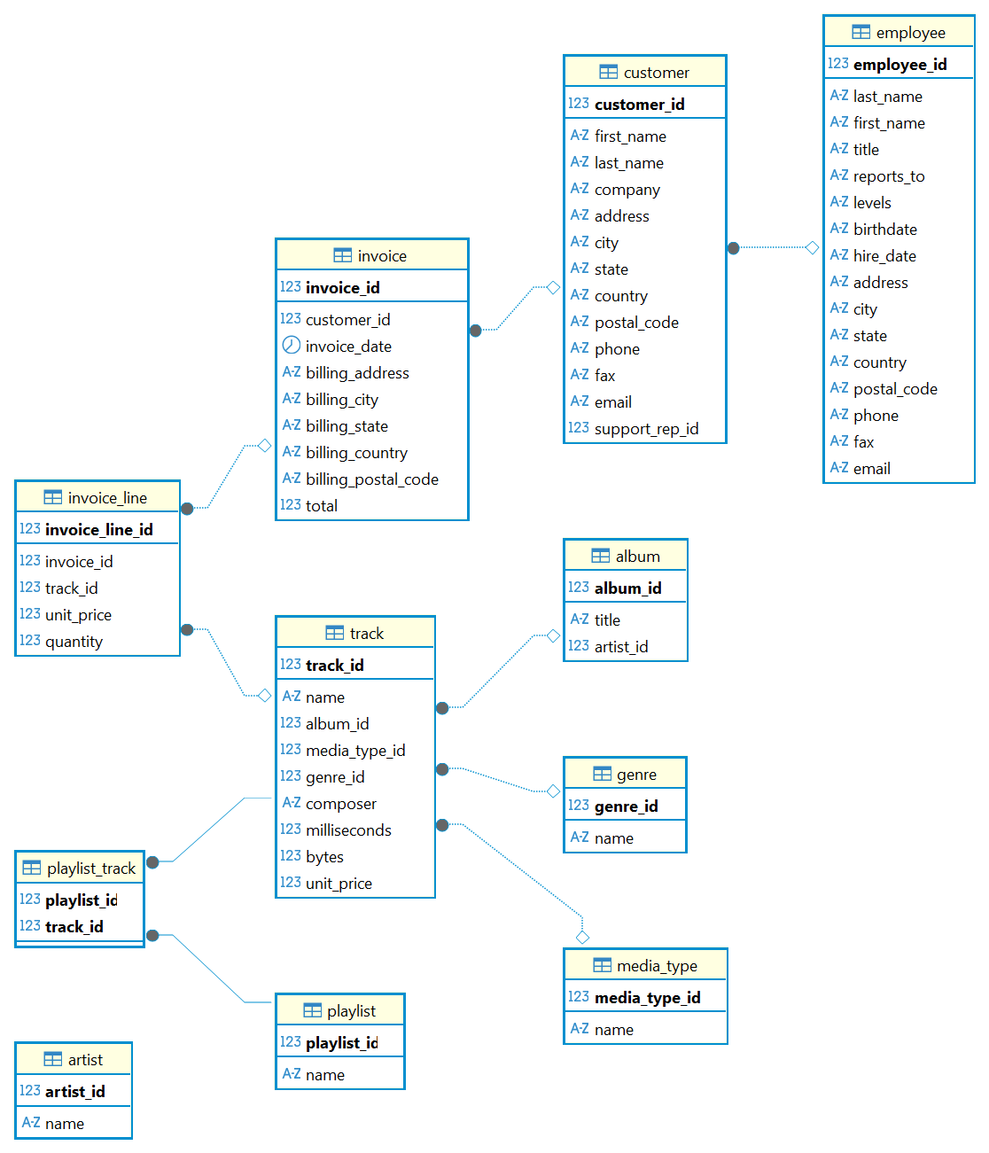

Additional Insights

As we navigate the intricate schema, every relationship and table offers a story of its own. The schema acts as a blueprint, guiding our journey through the structured symphony of the music store's data architecture.

Conclusion

In closing, this project navigates the intricacies of the music store dataset, revealing key insights and actionable strategies. From dataset analysis to toolset utilization and educational focus, each facet contributes to a comprehensive grasp of SQL's real-world application. Through meticulous examination and practical implications, the aim is to empower both businesses and learners.

